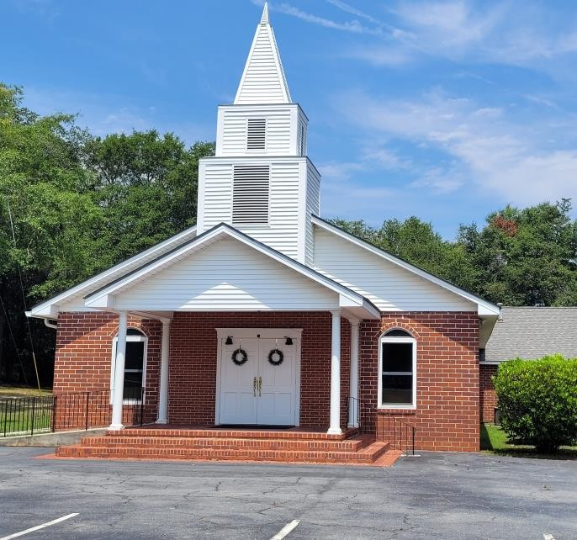
Memorial Heights Baptist Church
Statement of fAITH

2024
WE BELIEVE…

The Bible is the Inspired Word of God

The Bible as the eternal, inspired, inerrant Word of God; the complete revelation of God's will.

Proverbs 30:5
2 Timothy 3:16
2 Peter 1:20,21

God in Three Personalities

There is one true and living God in three
personalities: the Father, the Son, and the Holy Spirit.

2 Corinthians 13:14
Mattew 3:16, 17
Mattew 28:19

Biblical Account of Creation

We accept the complete Bible account of creation without question and unreservedly.

Genesis 1:1-2:2:25
John 1:3

Satan and Sin

Satan is the unholy god of this present age and
world-systems; He is the author of all of the powers of darkness and sin.

2 Corinthians 4:4
1 Peter 5:8

In the Image of God

Man was created in the image of God and, as a result of voluntary action, ate of the forbidden fruit and
was no longer innocent or worthy to walk with God; Man spiritually died.

Genesis 3:1-7
Romans 5:12

The Virgin Birth

We believe in the virgin birth as well as the deity of the Lord Jesus Christ; we believe he was God in the flesh.

Isaiah 7:14
John. 10:30
Luke 1:31-35

Atonement for Sins

The only atonement for sins is through the shed blood of our Lord and Savior Jesus Christ.

Acts 4:12
Hebrews 9:11-15
1 Peter 1:19, 20

Depravity of Man

We believe in the total depravity of man in that he cannot come to Christ without the drawing force of the Father in Heaven.

John 6:44
1 Corinthians 2:14
Romans 8:7, 8

Election

The unconditional election by God of man to salvation.

John 17:2
Ephesians 1:4,5
1 Corinthians 1:26-29

Blood of Christ

The shed blood of Jesus Christ covers each and every elect.
John 17:2
1 John 1:7
1 John 4:10

Calling of the Elect

We believe in an effectual calling that goes out to every elect whom God has chosen.

Romans 8:28-30
John 6:37
1 Corinthians 1:22-24

Born Again
All who are truly born again are preserved by God the Father and persevere through the Lord Jesus Christ.

Romans 8:35-39
1 Peter 1:4,5
John 10:27-29

Regeneration and Conversion

Regeneration and conversion is a simultaneous occurrence as a result of the Holy Spirit using the spoken or written word.

2 Thessalonians 2:13,14
Hebrews 4:2
1 Corinthians 1:21

Salvation

Salvation is totally by the pure grace, or unmerited favor, of God.

Jonah 2:9
Ephesians 2:8, 9
2 Timothy 1:9

Judgments

We believe in separate judgments for the righteous and unrighteous.

1Corinthians 3:12-15
2Timothy 4:7, 8
Revelation 20:11-15
1 Peter 3:7

Personal Ministry of Earth

Jesus instituted His church during His personal ministry on earth.

Mattew 16:18
Mark 3:13-19

Local Church

We believe in a local church; not an invisible, universal church.

Acts 14:23
1 Corinthians 14:33
1 Thessalonians 1:1

Two Ordinances of Jesus

Jesus Christ gave two ordinances to the churches: baptism and the Lord's Supper, or communion.

Mattew 26:26-29
Acts 2:41
1 Corinthians 11:14-16
Acts 19:4, 5

Baptism

Baptism is a complete immersion in water.

Mark 1:10
Acts 8:38. 39

A Believer's Baptism

We believe in a believers baptism; we believe one is baptized because he is saved and not in order to be saved.

Acts 2:41
Act. 8:12, 36, 37

Lord's Supper

The Lord's Supper is for each local church and not to be practiced openly with everyone.

1 Corinthians 10:16,17

Joining the Church

We do not believe in high-pressure methods of begging people to donate money or persuading people to join our church, we simply believe in preaching the gospel and leaving the results to the Lord.

Act. 2:47
2 Cor. 9:6, 7
1 Cor. 16:2

Sovereignty of God

We believe in the absolute and eternal sovereignty of God; that, presently and in the hereafter, all things will glorify God; everything from His saints, who will be with Him, to those who will spend eternity in the lake of fire, glory be to God.

Dan. 4:35
Ps. 76:10
Is 42:8
Jud. 25
Rev. 4:11

